Francis Vo  IPv4 Address: 10.0.0.2  IPv6 Address(optional): | Hanish Vadlamudi  IPv4 Address: 10.0.0.3  IPv6 Address(optional):
Myles Sartor  IPv4 Address: 10.0.0.4  IPv6 Address(optional): | Brandon Weber  IPv4 Address: 10.0.0.7  IPv6 Address(optional):

Web Server Screenshots:  Submit a screenshot of the web page you created (index.html) with the IP address visible in the browser's address bar. | Francis Vo: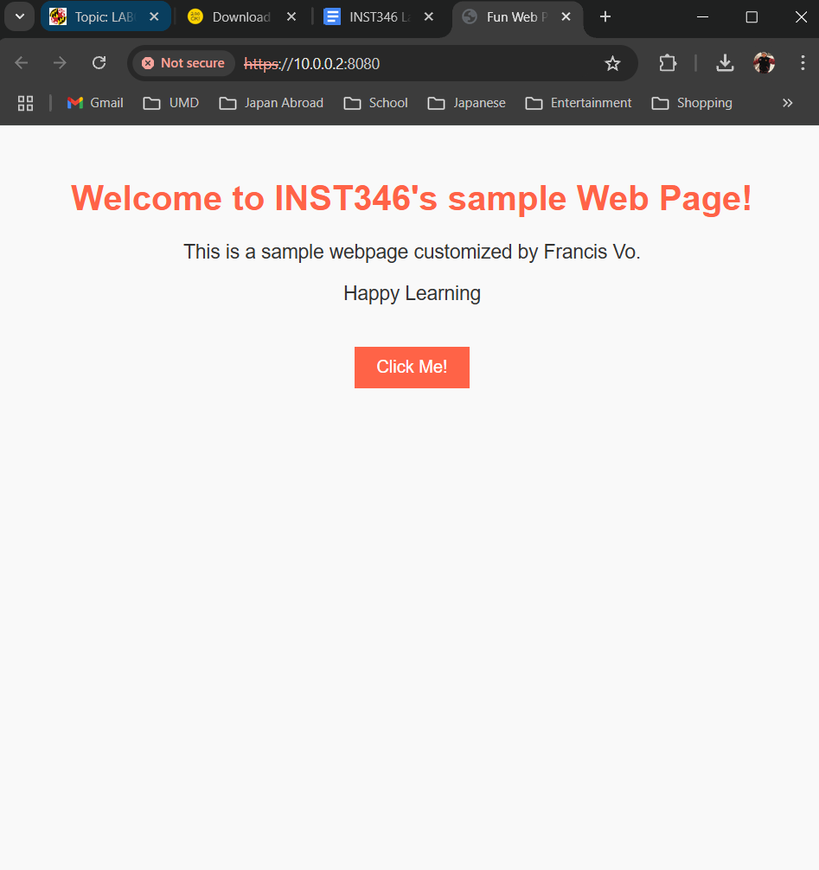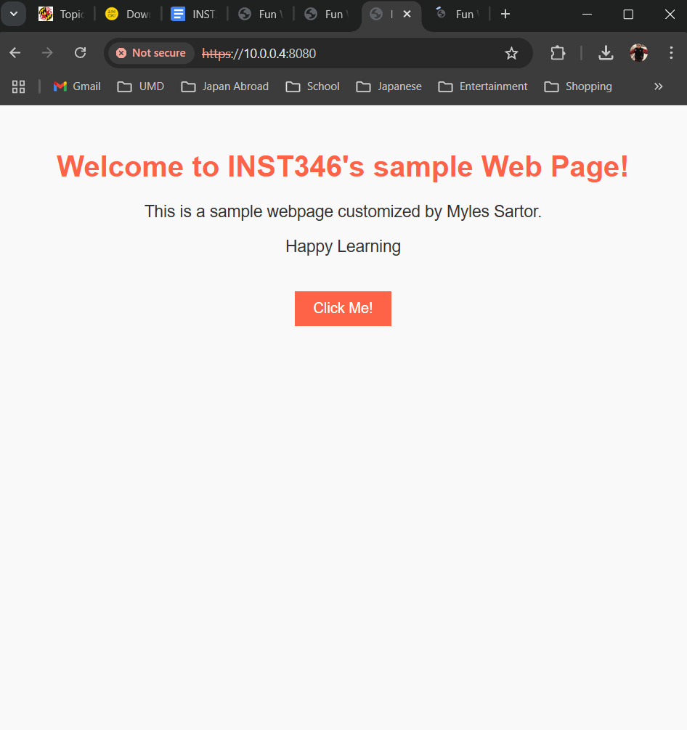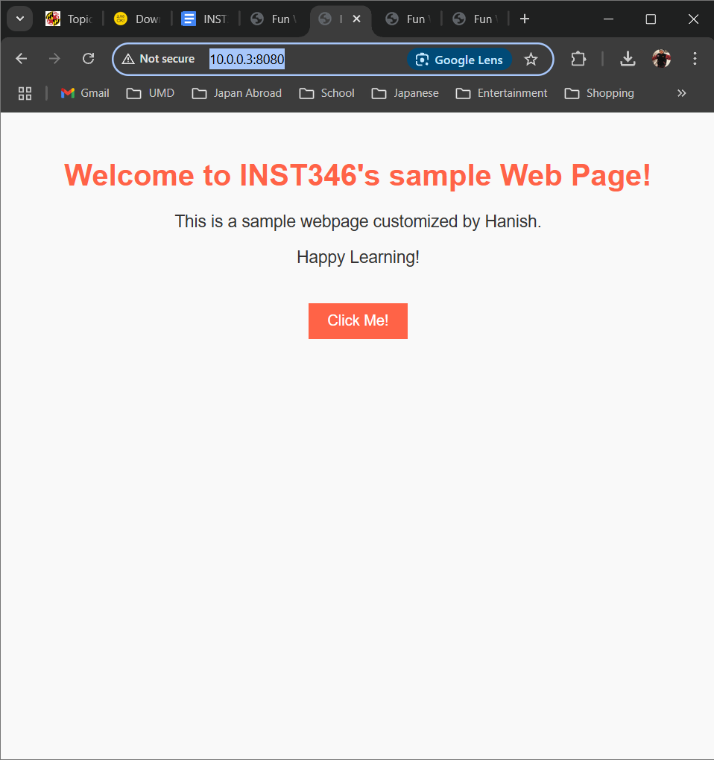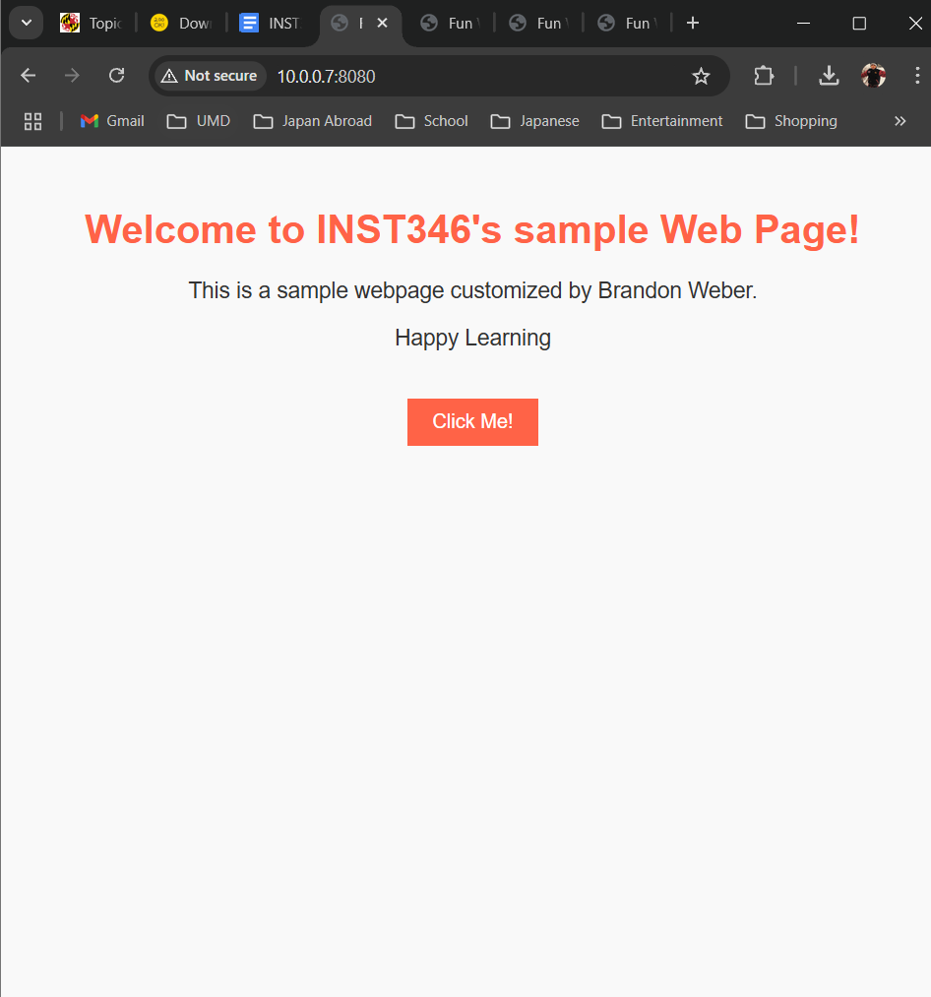  Myles Sartor: 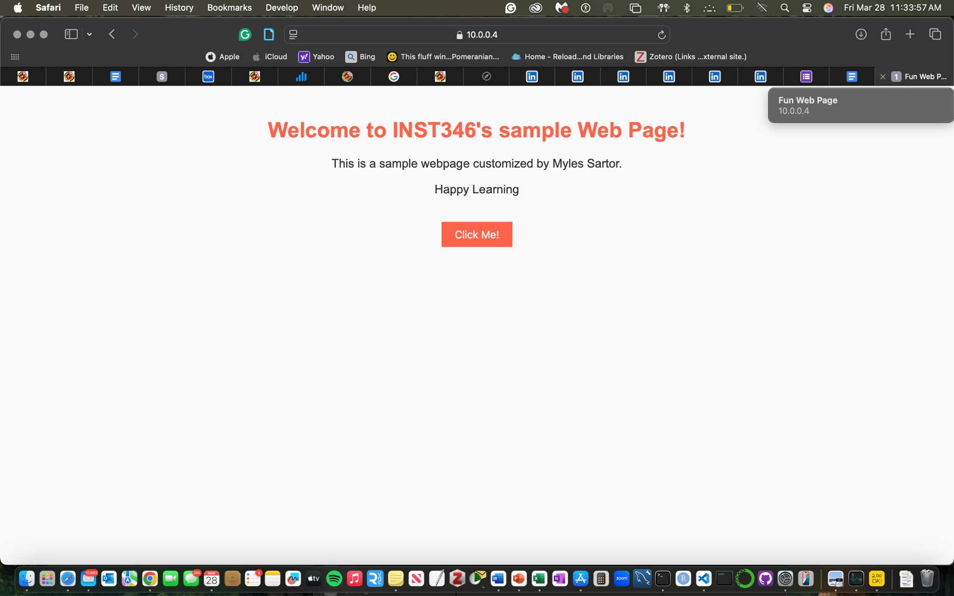  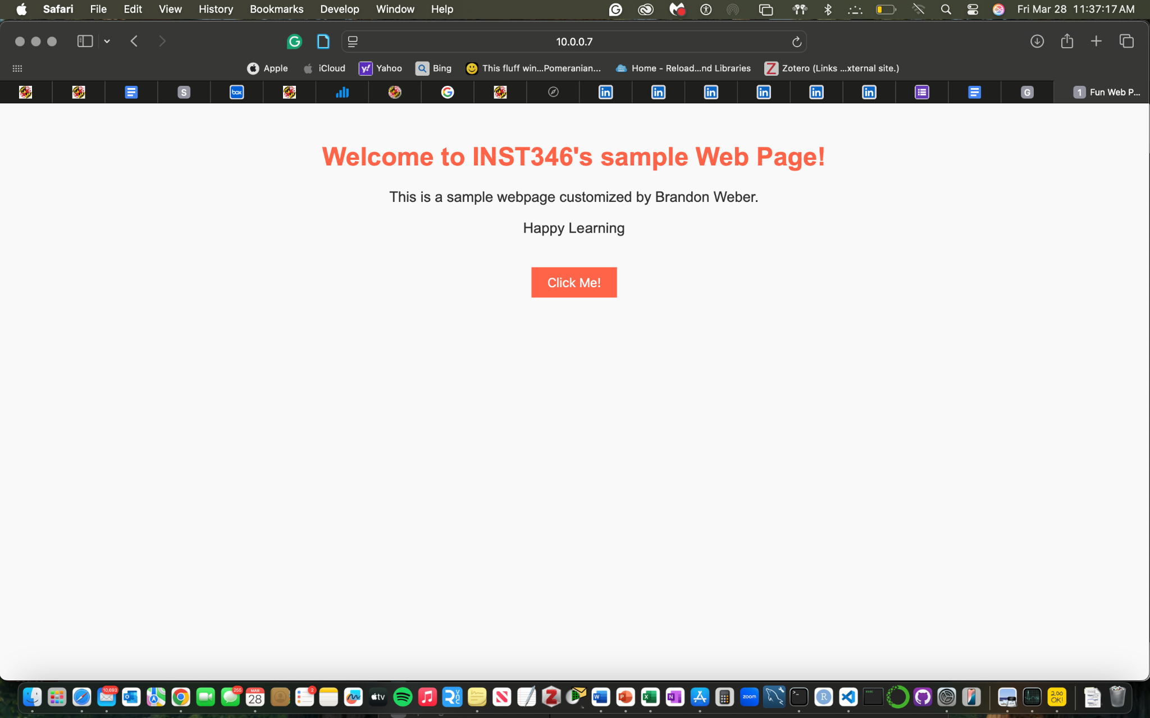  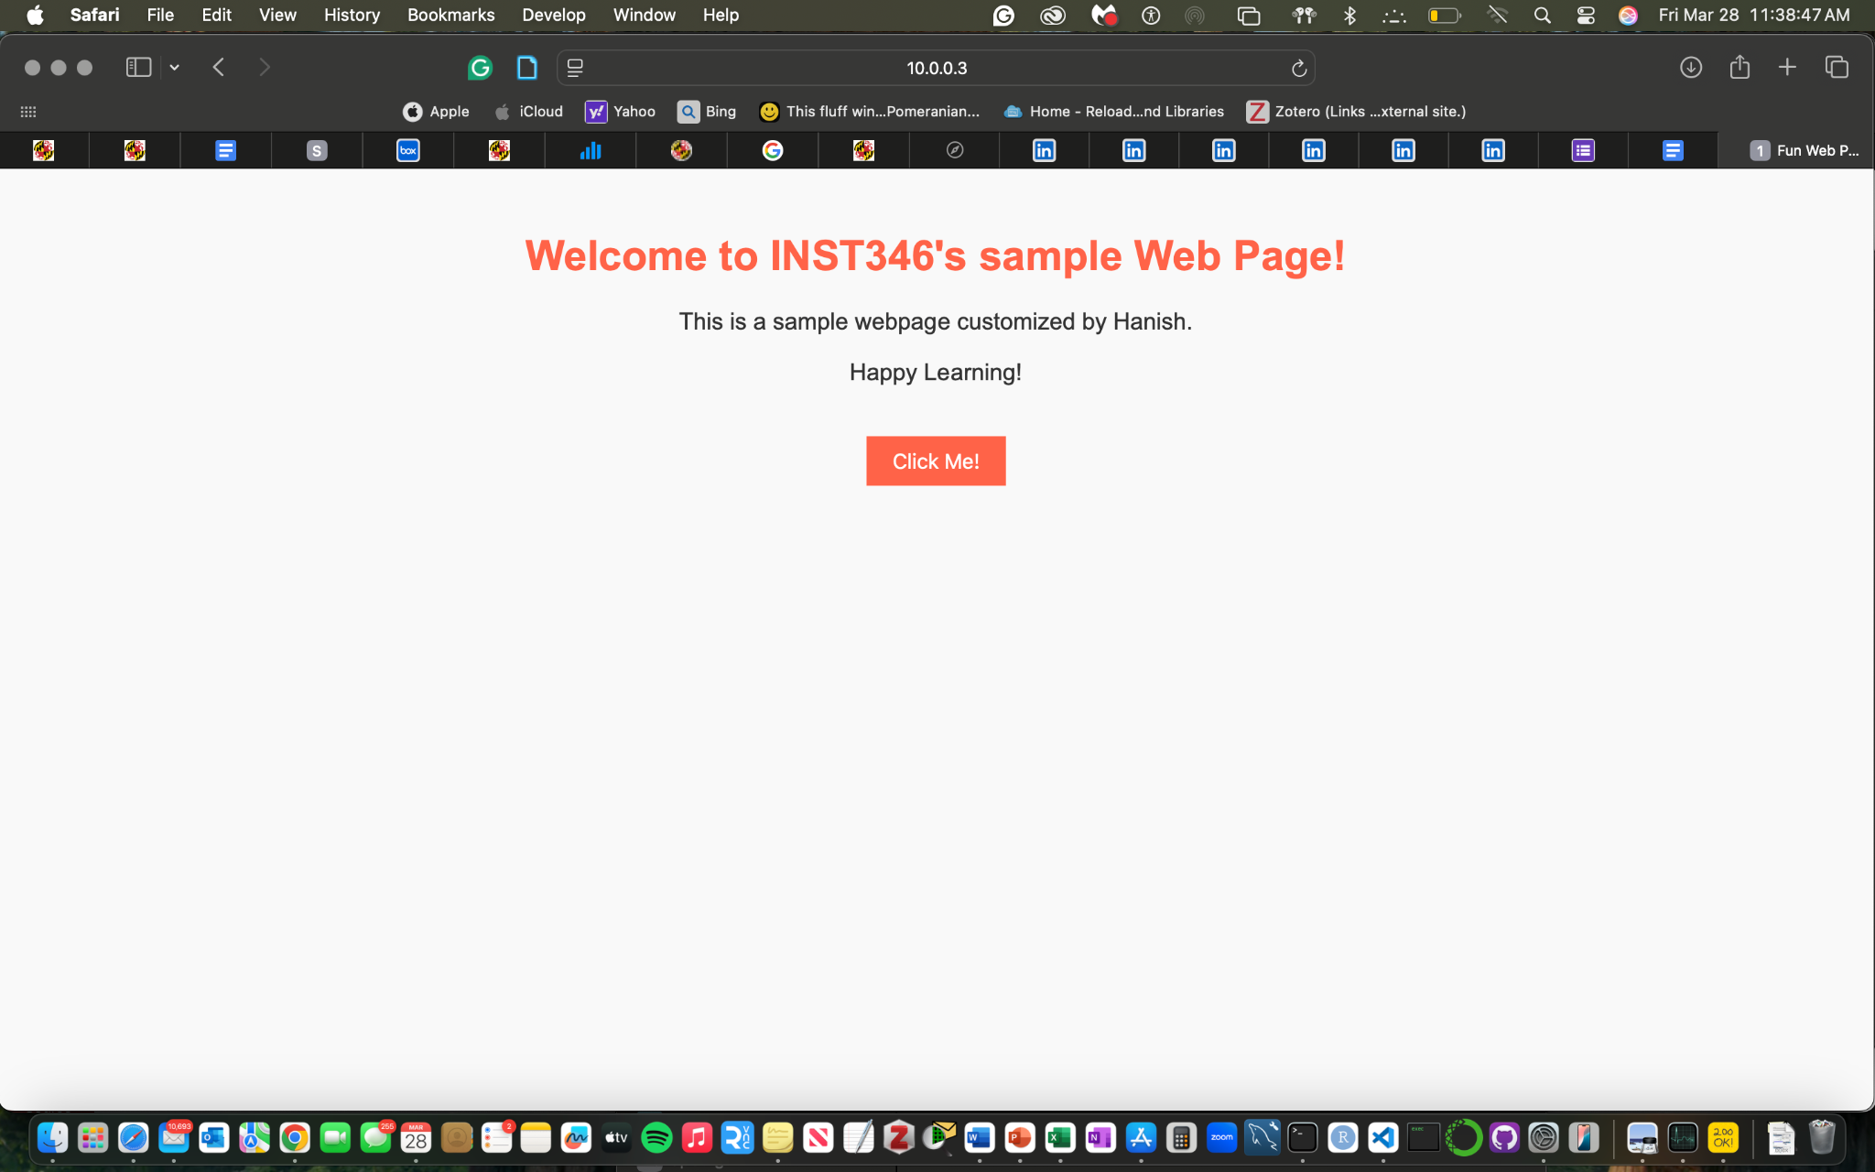  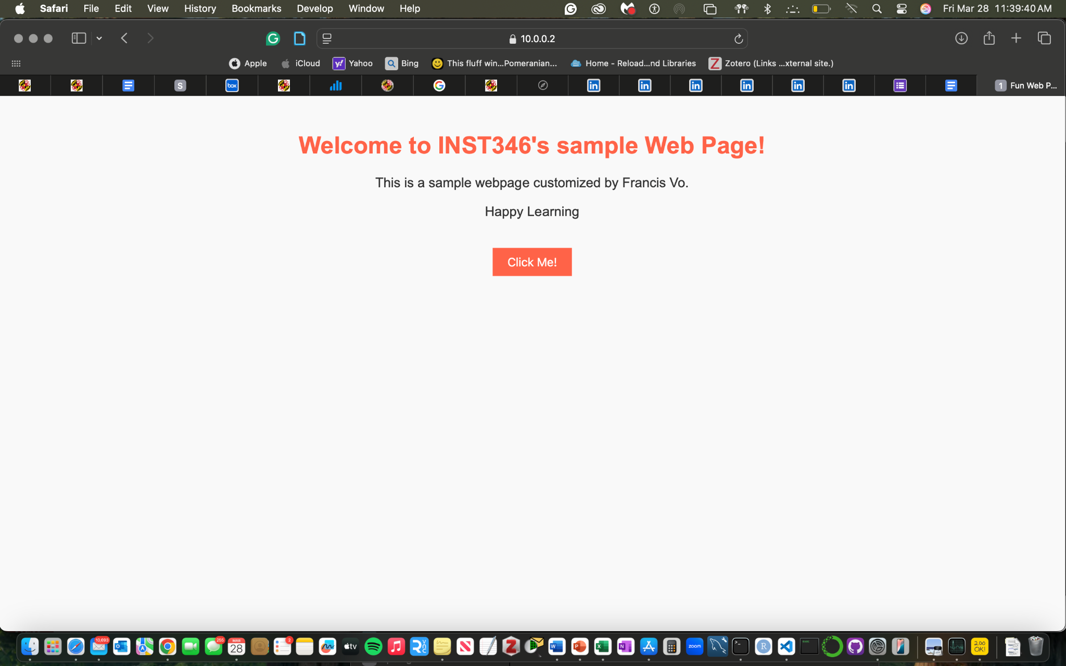  Brandon Weber: 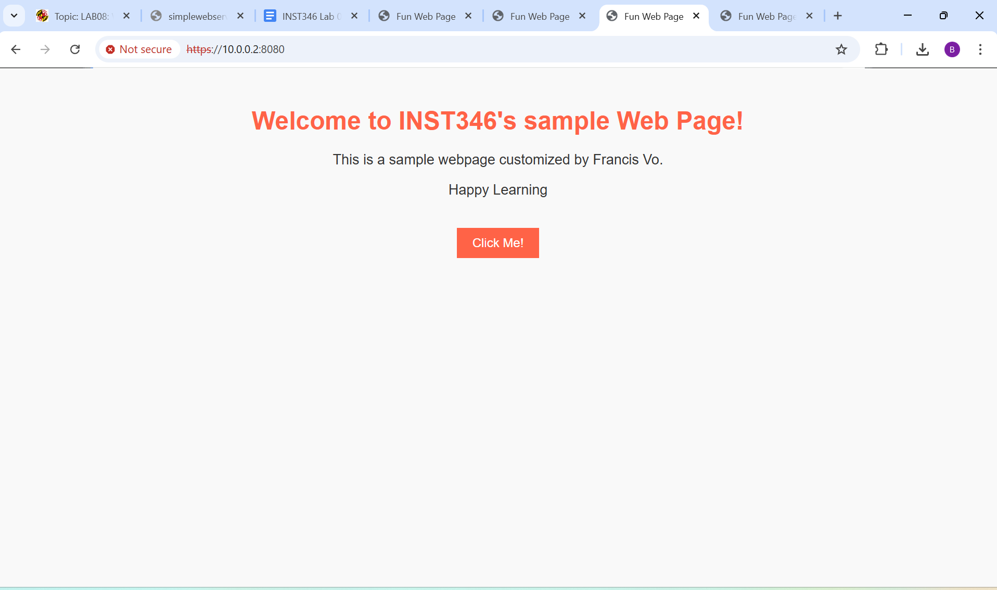  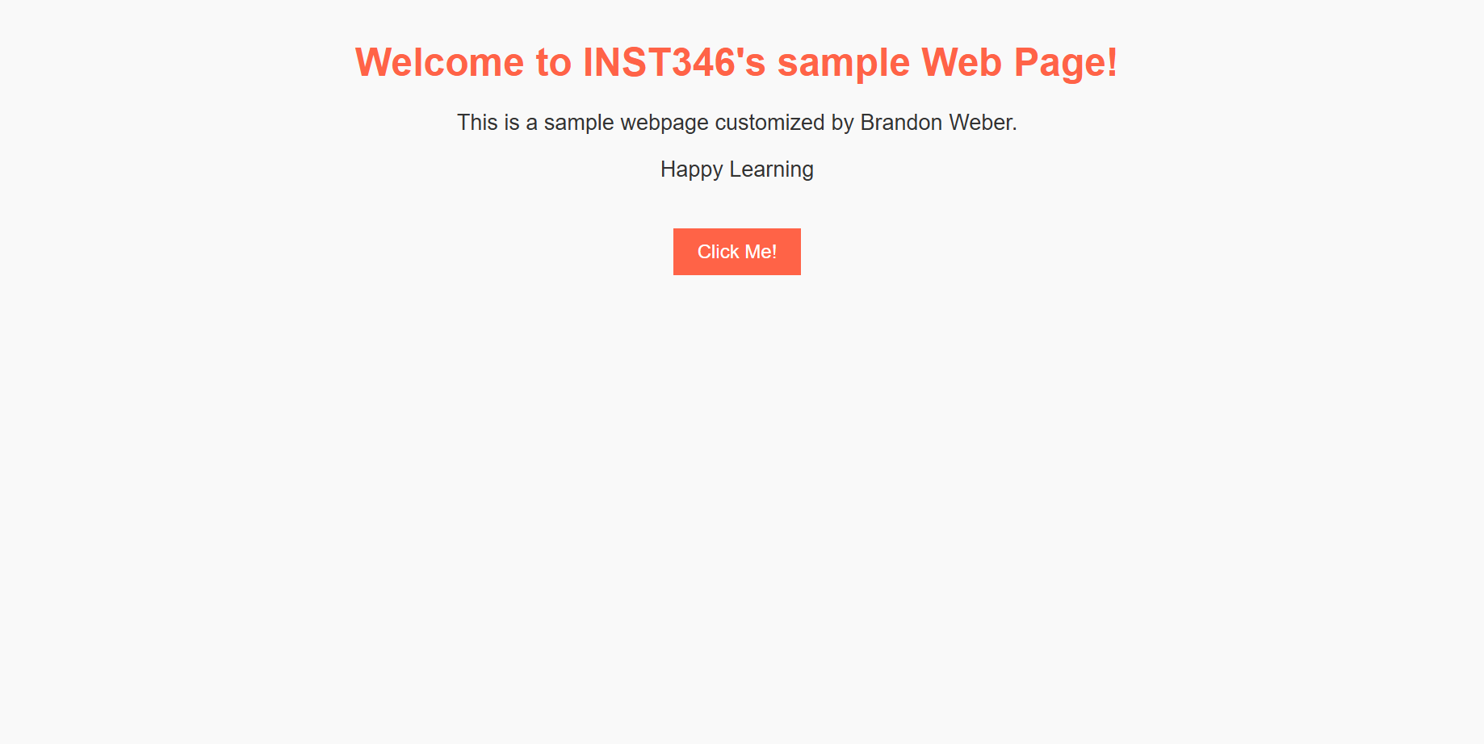  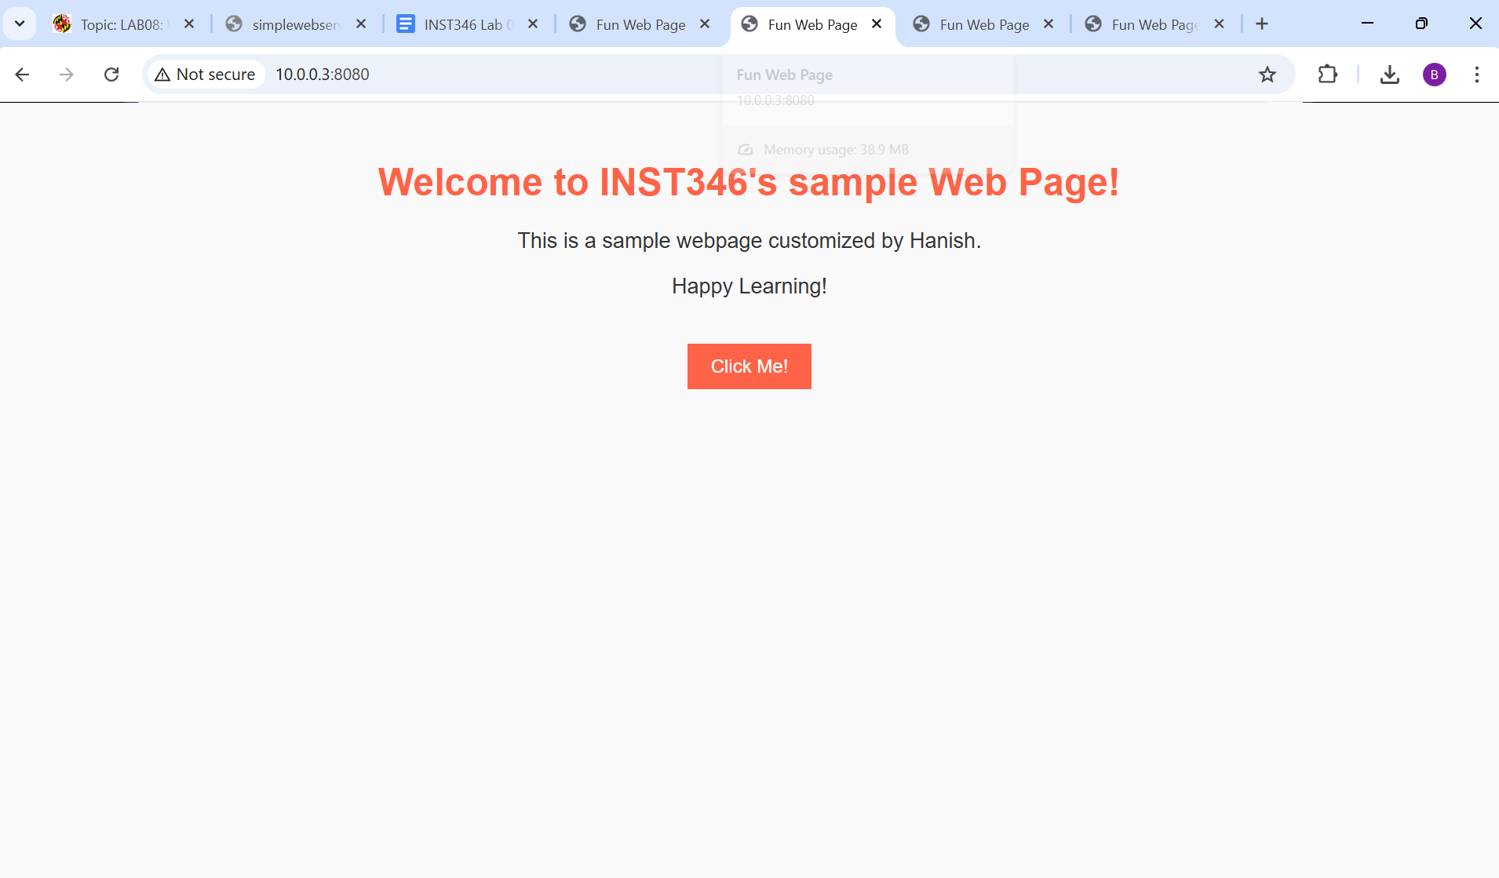  Hanish Vadlamudi: 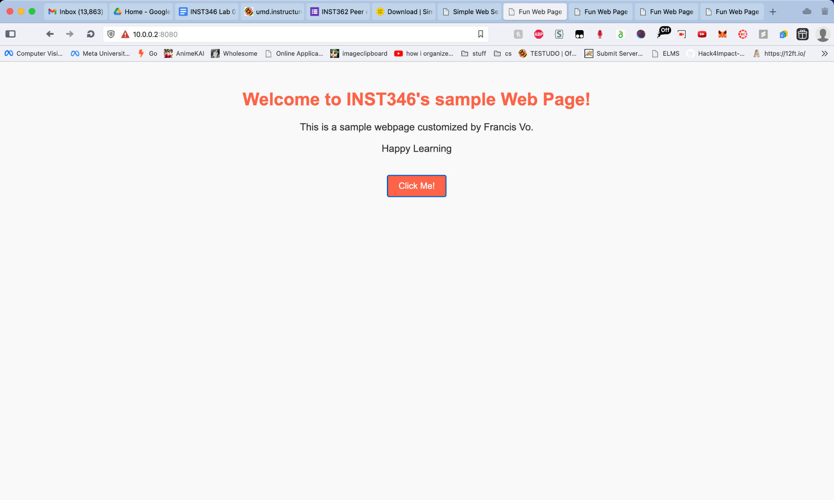  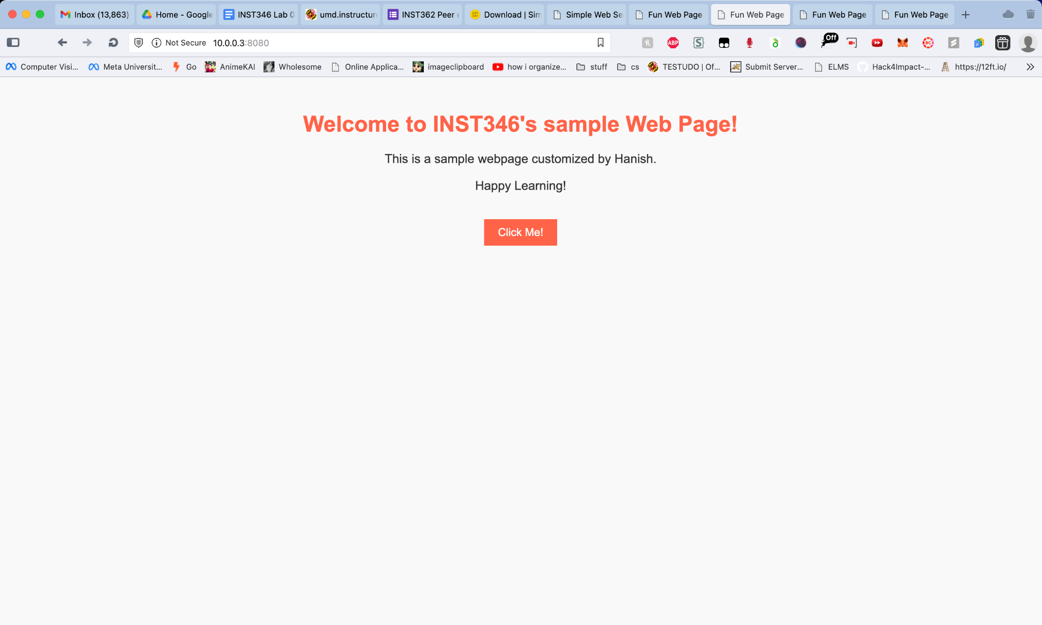  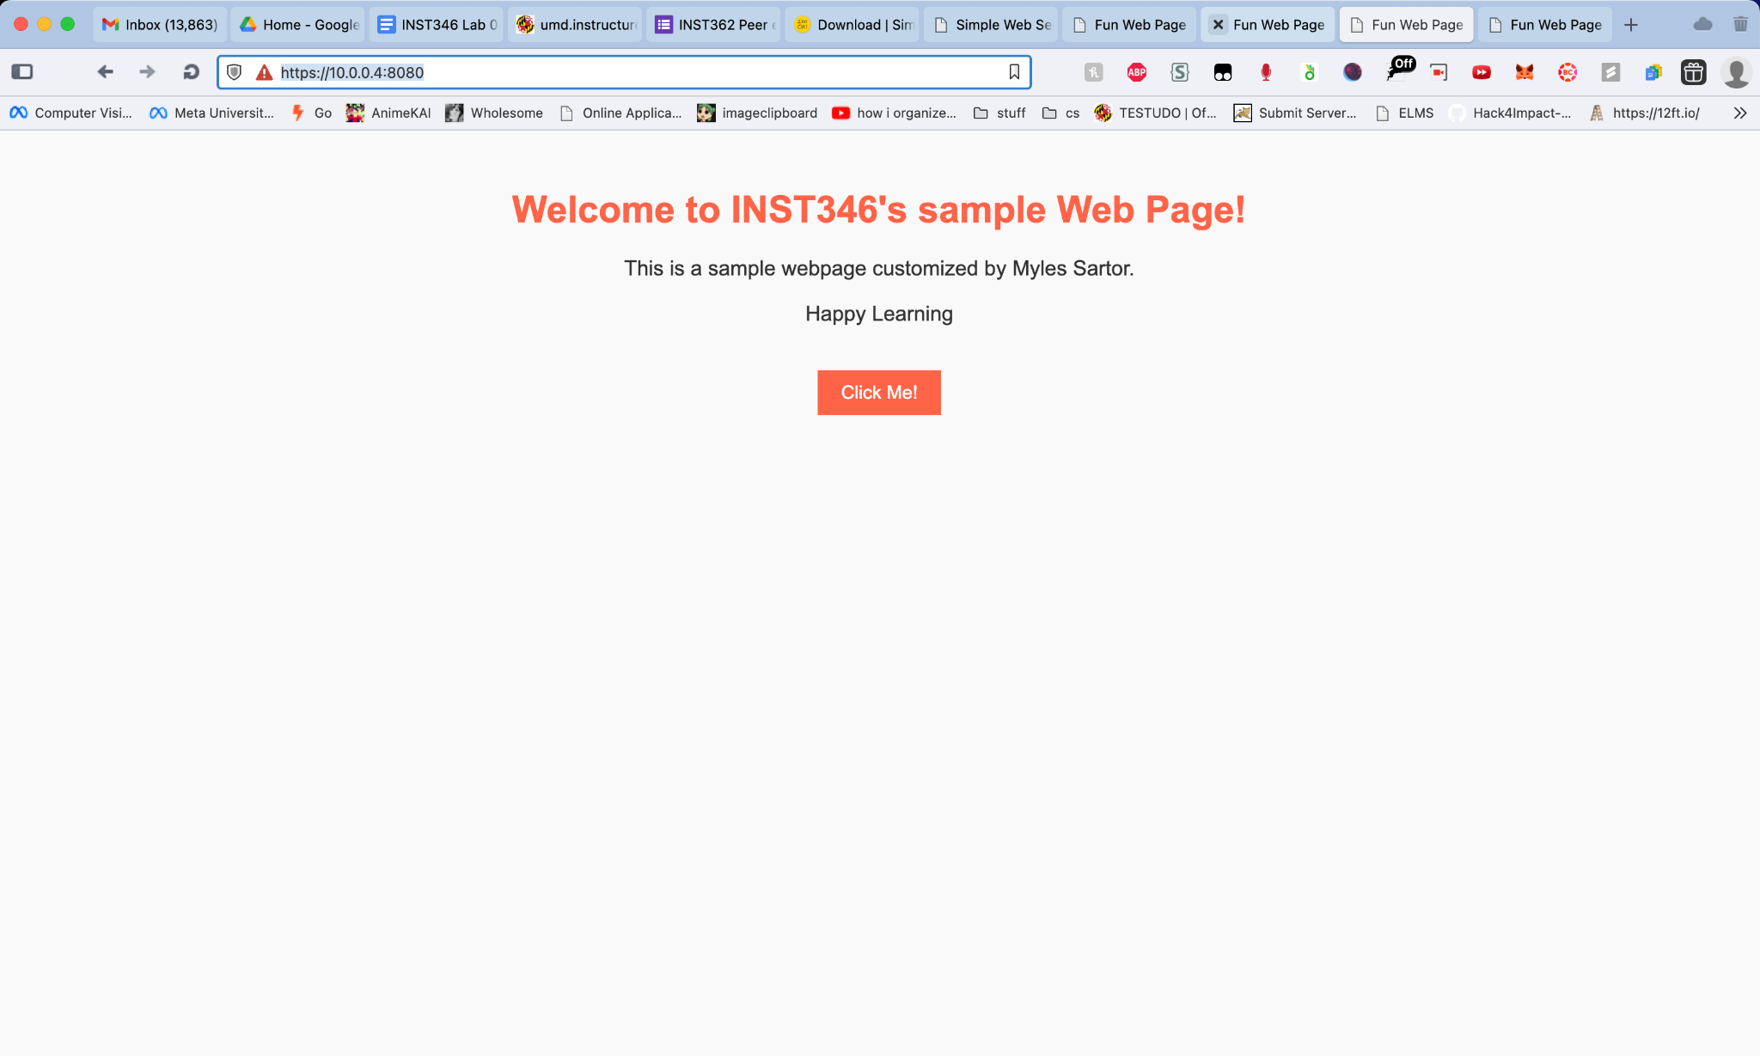  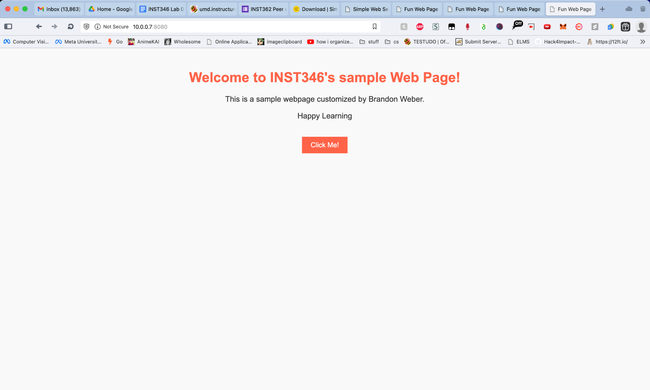
Reflection on Layer Interactions:  Which OSI model layers were involved in this lab? | TCP/IP OSI model layers were heavily utilized within this lab to map the IP addresses to their respective websites and port numbers, allowing each computer to effectively communicate with one another.
Command Line Outputs:  Submit the output of your ping tests showing successful communication between devices. (Command Prompt/Terminal). | Hanish: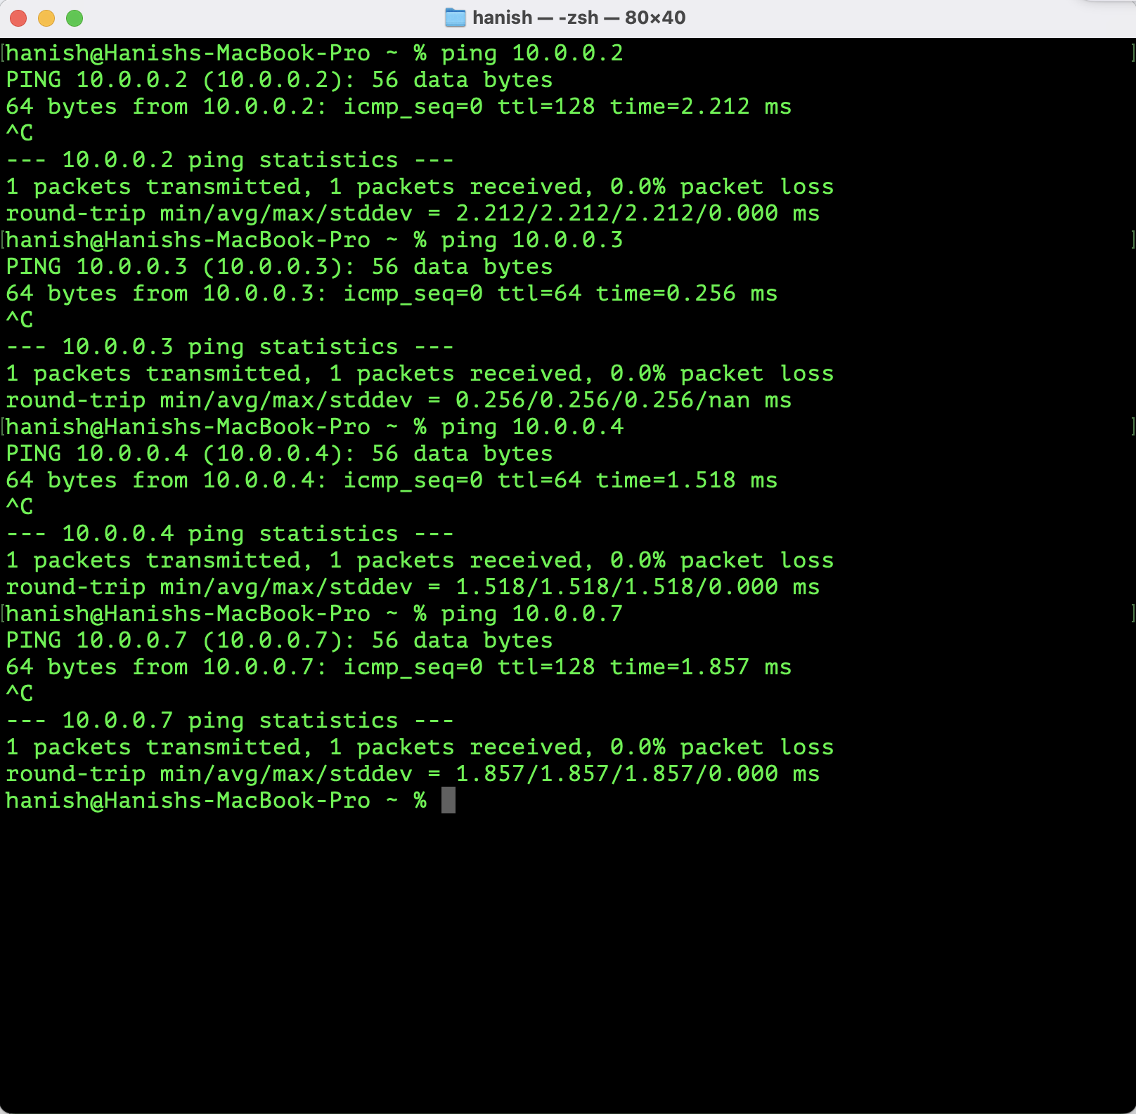  Francis Vo: 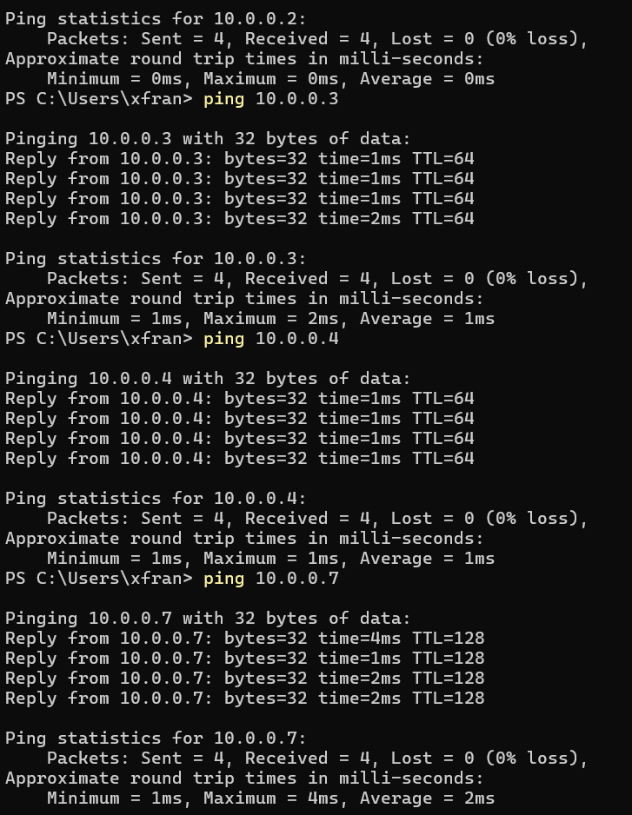  Myles Sartor: 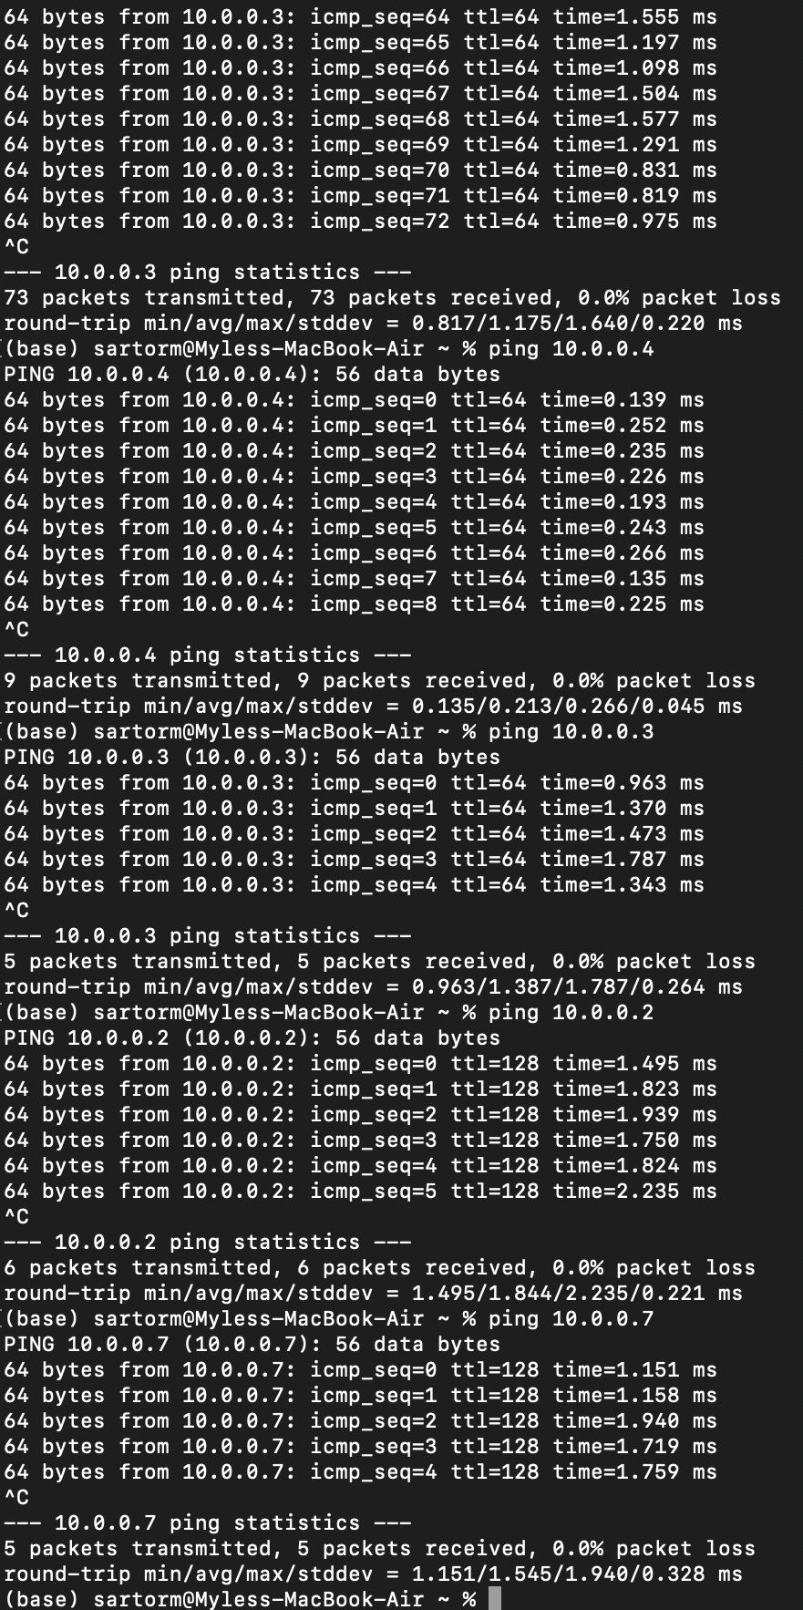
Reflection on Steps Taken  Write a short paragraph reflecting on what steps you performed to complete this lab. | We just followed the steps one by one. First you connect all computers to the switch. Then you make sure you manually input IP so it is easier to keep track of who is who. Ping test everyone to see if everyone is connected properly. Then each of us creates our own server on our laptops. Then we host an index file on the server. We edit the file, and access each other's server to test if the file is being displayed properly and the server working properly.
Connection Testing Method  What method did you use to check if the devices were connected and able to communicate?  Instructions:  - Explain how you tested the connection between the devices, such as using ping.  - Describe what results you saw that indicated successful communication. | One submission per group  We used the terminal to ping each other IP’s in order to see if there was a successful reply.  Once we all individually set up our webpages, we input and tested everyone's webpage ip to see if it would show up, which it did.
Troubleshooting Log:  Create a log of any troubleshooting steps taken during the lab (list the issue, steps taken, and solution). (e.g., checking IP configurations, restarting devices, etc.). | Hanish solved the error. Brandon was having an error connecting to some of our group's devices. I checked the url of the ip he was trying to open, and it turns out he didn't have https secured, just http. So resolving the url to https worked.
Future Recommendations:  Based on your experience in this lab, provide a few recommendations on what you think could have been more useful if included and our space for improvement. | Francis Vo: explanation of certain checkboxes, such as the security and basic options tab  Myles Sartor: I think a more in depth discussion of how the server grabs information from the HTML file should’ve been included.  Hanish Vadlamudi: if only one person had to submit a picture of everyone's website working that would be better.  Brandon Weber: If there was clearer instructions on how to get firewalls down

